**Pollinator Garden Planner**

Installation Manual

North Carolina State University

Department of Applied Ecology

CSC 492 Team 5:

Kevin Bartushak

Noel Drotor

Tammy Le

Carolyn Thompson

North Carolina State University

Department of Computer Science

December 14, 2018

**Introduction** **2**

**Product Build and Installation** **3**

Build 3

Install 3

Security 3

**Troubleshooting Guide** **4**

Common Problems 4

**Verification Plan** **5**

Web Requests 5

Program Output 5

Introduction

The following installation guide will identify tasks required for project build and installation. The Pollinator Garden Planner is a web application, so this guide will provide instructions for installing a production web server and guidelines and suggestions for improving the security of deployment.

Product Build and Installation

Build

Steps

1. In Visual Studio Code, Select Terminal 🡪 New Terminal
2. In the terminal window, type:

ng serve

1. Click link: <http://localhost:4200/> in the terminal to launch Pollinator Garden Planner website.

Install

The root of the project folder contains two batch script files that may only be run on Windows machines. These files can be run from the file explorer or through the command prompt window by switching to the root of the project folder.

1. Setup.bat should be run one time at the beginning of the semester. Anytime you want to run the application, run the file run.bat.

Security

It is recommended that the application is run under HTTPS considering that when UC1 and UC2 are implemented (creating an account and logging in), a user will have login information like an email address associated with their account.

Troubleshooting Guide

Common Problems

Build Problem

If the “ng serve” command fails with the message “Port 4200 already in use”:

1. Open cmd.exe as administrator
2. In the terminal window, type:

netstat -ano | findstr :4200

1. Note the PID number located in the right-most column beside “LISTENING”. In the terminal window, type:

taskkill /PID [insert PID number] /F

Replace “insert PID number” with the PID you noted in the above step. Now you should be able to launch the application as normal with “ng serve”.

Prevention

To avoid the above error, terminate the batch job in the Visual Studio Code terminal when you are done using the website. To do so, type on the keyboard:

Ctrl + C

You will be prompted “Terminate batch job (Y/N)?” Type “Y” and enter.

Verification Plan

Program Output

The project UI in its most recent state should look like the below images.

Login

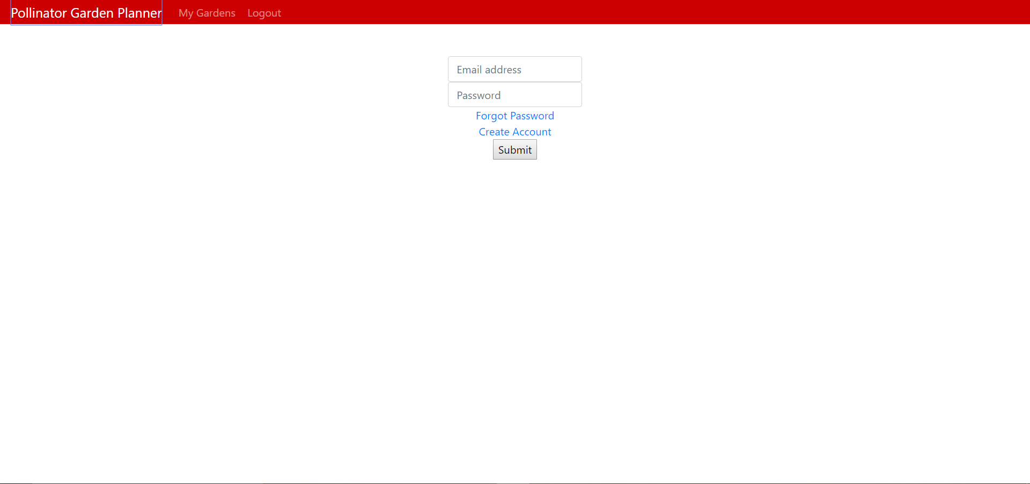

Create Account

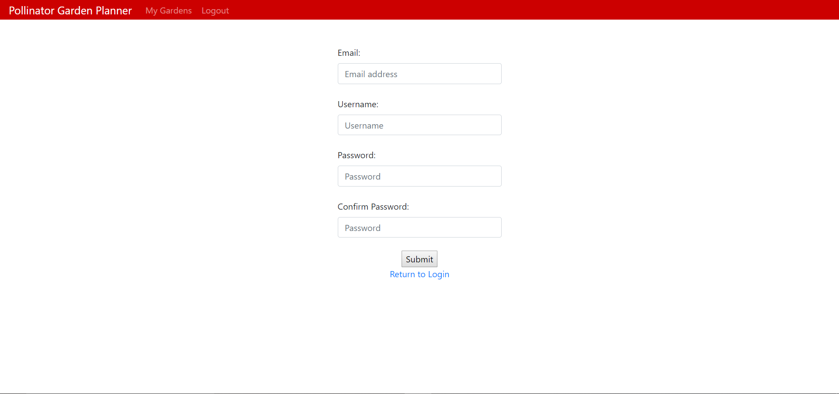

Forgot Password

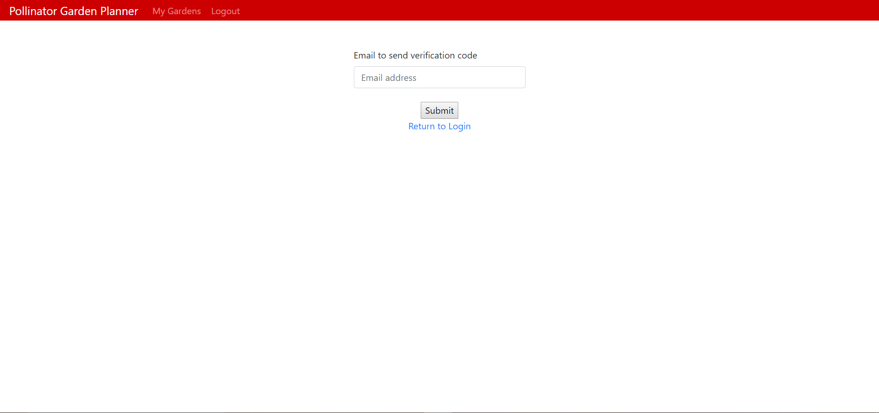

Create New Garden/Open Existing Garden

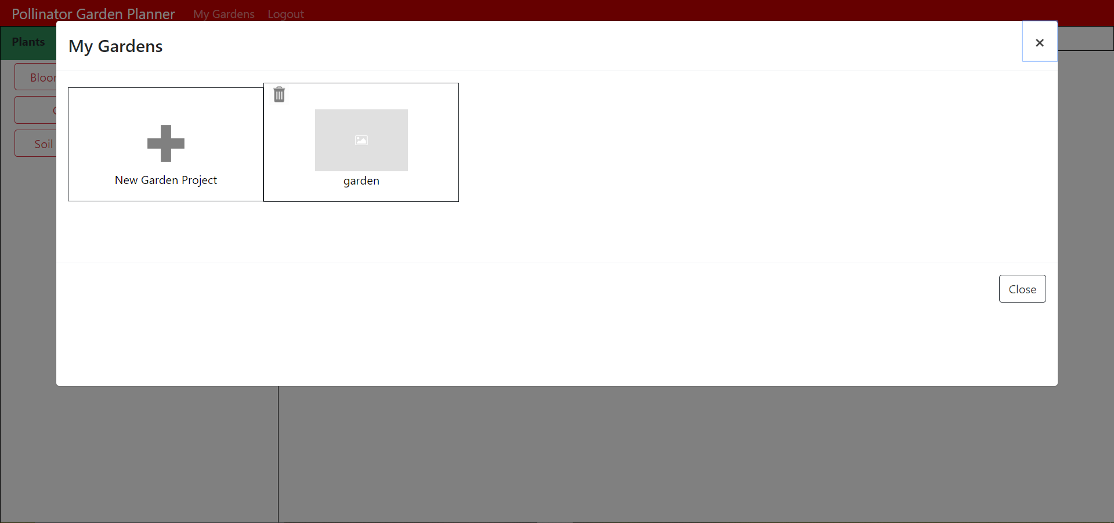

Edit Garden, Search and Filter Plants

